St. John Summer Math Packet 2014
Incoming 7th Grade

Complete this packet throughout your summer vacation. I recommend giving yourself a couple of weeks before starting it, but this packet will help keep your memory fresh on all that you learned in 6th grade.

This packet is NOT mandatory, but it is HIGHLY RECOMMENDED in order to be prepared for 7th grade.

If you submit your packet to Mrs. Catalan during the FIRST WEEK OF SCHOOL, I will give you a reward for completing it. =)

Please feel free to do more practice on your own with websites such as: http://www.softschools.com/grades/6th_and_7th.jsp

Have a wonderful summer!

Blessings,

Ms. Hansen

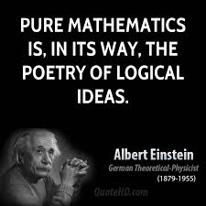

To add and subtract decimals, make sure the decimal points are lined up. Add zeros after the decimal point when needed.

EX: $67.21-49.372$ $67.210$
$-49.372$
17.838

1. $22.9+13.85$ 2. $5.92-4.38$ 3. $2.1-1.9$

ANS: 36.75 ANS: 1.54 ANS: 0.2

4. $17.56-3.42$ 5. $3.1+0.789$ 6. $41.24+9.273$

ANS: 14.14 ANS: 3.889 ANS: 50.513

To multiply decimals, multiply as normal and then count how many decimal places your factors have. That is how many decimal places your answer needs to have.

EX: $3.65 × 2.1$ $365$ *3.65 has 2 decimal places and 2.1 has one =
$× 21$ total of 3 decimal places in the answer.
365
+7300
7665 7.665 as final answer

7. $52.33 × 4.5$ 8. $1.924 × 7.2$ 9. $3.456 × 2.82$

ANS: 235.485 ANS: 13.8528 ANS: 9.74592

To divide decimals, make sure your divisor is a whole number. If it isn’t, move the decimal point the number of places necessary. You then must also move the decimal point in the dividend the same number of places.

EX: $6.24 ÷ 3$ EX: $4.267 ÷ 0.05$
10. $95.04÷22$ 11. $226÷8$ 12. $36÷0.8$

ANS: 4.32 ANS: 28.25 ANS: 45

13. $14.35÷0.41$

ANS: 35

14. You and your 5 friends by a pizza to share. The pizza costs $15.90. How much money should you each pay for the pizza?

ANS: You should each pay $2.65

15. At the grocery store you buy everything you need to bake a cake. You gave the cashier $20.00 and got $4.31 back in change. How much did your groceries cost?

ANS: Your groceries cost $15.69

To add and subtract fractions and mixed numbers, you need to have a common denominator. With mixed numbers, if you are unable to subtract the fractions you must regroup from the whole number. Always put your answer in simplest form.

EX: $\frac{7}{8}-\frac{3}{8}$ EX: $3\frac{1}{7}-1\frac{1}{3}$

16. $\frac{4}{15}+\frac{8}{15}$ 17. $6\frac{7}{9}+3\frac{5}{12}$ 18. $\frac{7}{10}-\frac{1}{6}$

ANS: $\frac{4}{5}$ ANS: $10\frac{7}{36}$ ANS: $\frac{8}{15}$

19. $8\frac{2}{7}-1\frac{5}{14}$ 20. $4\frac{5}{12}-2\frac{1}{12}$ 21. $\frac{3}{8}+\frac{19}{24}$

ANS: $6\frac{13}{14}$ ANS: $2\frac{1}{3}$ ANS: $1\frac{1}{6}$

To multiply fractions, multiply the numerators and multiply the denominators. *Remember the song!* You may also cross cancel. Make sure your answer is in simplest form.

To multiply mixed numbers, change them to improper fractions, then follow the multiplication of fractions rules. Make sure your answer is in simplest form, which may mean changing it back to a mixed number.

EX: $\frac{3}{8}×\frac{2}{5}$ EX: $3\frac{1}{3}× 4\frac{1}{2}$
22. $\frac{5}{9}×\frac{3}{5}$ 23. $\frac{3}{7}∙\frac{4}{9}$ 24. $2\frac{1}{9}× 1\frac{1}{2}$

ANS: $\frac{1}{3}$ ANS: $\frac{4}{21}$ ANS: $3\frac{1}{6}$

25. $6∙\frac{8}{21}$ 26. $5∙2\frac{2}{5}$ 27. $3\frac{5}{6}× 4\frac{2}{3}$

ANS: $2\frac{2}{7}$ ANS: $12$ ANS: $17\frac{8}{9}$

To divide fractions, multiply the first fraction by the reciprocal of the second fraction. *Remember the song!* Don’t forget to put your answer in simplest form.

To divide mixed numbers, change to improper fractions and follow the division of fractions rules.

EX: $\frac{2}{3}÷\frac{8}{9}$ EX: $2\frac{1}{3}÷1\frac{3}{4}$

28. $\frac{1}{9}÷\frac{3}{5}$ 29. $5÷\frac{10}{11}$ 30. $\frac{3}{5}÷\frac{6}{7}$

ANS: $\frac{5}{27}$ ANS: $5\frac{1}{2}$ ANS: $\frac{7}{10}$

31. $2\frac{3}{7}÷3\frac{1}{2}$ 32. $5\frac{1}{4}÷5\frac{1}{3}$

ANS: $\frac{34}{49}$ ANS: $\frac{63}{64}$

33. A stack of books is 36 inches high. If each book is $\frac{3}{4}$ in. thick, how many books are stacked together?

ANS: There are 48 books.

34. Silvia buys $1\frac{2}{3}$ yd. of blue fabric and $2\frac{4}{5}$ yd. of purple fabric. How many total yards of fabric does Silvia buy?
To simplify expressions, follow the rules of PEMDAS. Remember: a fraction bar acts like parentheses: you must simplify the numerator and denominator first before simplifying the rational value.

EX: $\left(2^{3}-5\right)-(2∙5-8)$

ANS: Silvia buys 1$\frac{7}{15}$ yd. of fabric in all.

35. $12+15÷5$ 36. $6÷2∙4-1$

ANS: 15 ANS: 11

37. ${ (7-4)}^{2}+5∙6$ 38. $\frac{(10-4)∙2}{2+1}$

ANS: 39 ANS: 4

Add, subtract, multiply, and divide integers
*Remember: when subtracting integers, you add the opposite.
*Remember: when multiplying and dividing integers, if both numbers are the same sign the answer is positive; different signs gives a negative answer.

EX: $-3+4=1$ EX: $-2-3=-2+\left(-3\right)=-5$ EX: $-4\left(5\right)=-20$

39. $-3+8$ 40. $-3+(-6)$ 41. $7+(-13)$

ANS: 5 ANS: $-9$ ANS: $-6$

42. $-11-21$ 43. $3-10$ 44. $10-(-4)$

ANS: $-32$ ANS: $-7$ ANS: 14

45. $-3(4)$ 46. $\frac{-15}{-3}$ 47. $-6(-7)$

ANS: $-12$ ANS: 5 ANS: 42

Writing expressions: use a variable for what you do not know. Always translate left to right. *Remember: when you see “less than” it means you switch the order.

EX: Two less than a number => $x-2$ EX: Two less a number => $2-x$

48. The sum of a number and three 49. The product of six and a number

ANS: $x+3$ ANS: $6x$

50. Seven less than a number

ANS: $x-7$

Solving equations: The goal is to figure out what the variable needs to be in order to make the equation true. Use the opposite operation to solve for the variable.

EX: $x-9=20$ EX: $-3x=21$ EX: $x+4=-8$
51. $x+3=-7$ 52. $-2x=16$ 53. $x-3=-1$

ANS: $x=-10$ ANS: $x=-8$ ANS: $x=2$

54. $-5x=-35$ 55. $x-9=-9$ 56. $x+8=3$

ANS: $x=7$ ANS: $x=0$ ANS: $x=-5$

Solving and graphing inequalities: solve as you would an equation.
Graphing: less than or greater than = open circle; less than or equal to/greater than or equal to = closed circle.

EX: $x<3$ EX: $x-4≥-2$

57. $x>5$ 58. $x-3≤-1$ 59. $3x<9$

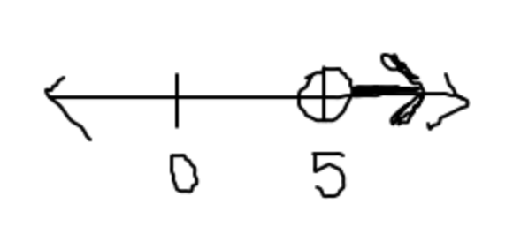 ANS: $x≤2$ ANS: $x<3$
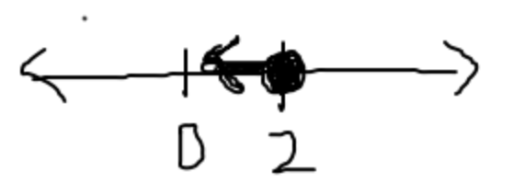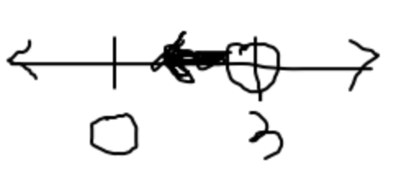

Fractions, decimals, and percents
Fractions to decimals: use long division
Fractions to percents: create an equivalent fraction with a denominator of 100 (since percents are out of 100), and the numerator is the percent
Decimals to fractions: the decimal place tells you what the denominator is
Decimals to percents: move the decimal point to the right two places (multiply by 100)
Percents to fractions: write the percent out of 100 and simplify
Percents to decimals: move the decimal point to the left two places (divide by 100)

EX: Write 0.24 as a fraction and percent

For problems 60-62, write each fraction as a percent and decimal.

60. $\frac{3}{5}$ 61. $\frac{7}{10}$ 62. $\frac{3}{4}$

ANS: 0.6; 60% ANS: 0.7; 70% ANS: 0.75; 75%

For problems 63-65, write each percent as a fraction in simplest form and a decimal.

63. 65% 64. 28% 65. 76%

ANS: $\frac{13}{20}$; 0.65 ANS: $\frac{7}{25}$; 0.28 ANS: $\frac{19}{25}$; 0.76

For problems 66-68, write each decimal as a percent and fraction in simplest form.

66. 0.52 67. 0.98 68. 0.27

ANS: $\frac{13}{25}$; 52% ANS: $\frac{49}{50}$; 98% ANS: $\frac{27}{100}$; 27%

69. Find the area and perimeter of the 70. Find the area of the triangle.
Area and Perimeter
Perimeter = distance around a polygon
Area of Triangle: $\frac{1}{2}bh$
Area of Rectangle/square: $bh$
Area of Parallelogram: $bh$
Area of Trapezoid: $\frac{1}{2}\left(b_{1}+b_{2}\right)h$
Volume of Rectangular Prism: $l∙w∙h$
Surface Area: Find the area of all the faces
and add (draw a net to help)
rectangle.

6 in
4 cm

9 in
5 cm

ANS: Area: 20 ${cm}^{2}$ ANS: Area: 27 ${in}^{2}$
Perimeter: 18 $cm$

71. Find the area and perimeter of the 72. Find the area of the triangle.
rectangle.

3 in
7 cm

10 in
8 cm

ANS: Area: 56 ${cm}^{2}$ ANS: Area: 15 ${in}^{2}$
Perimeter: 30 $cm$

73. Find the area of the parallelogram.

4 cm

5 cm

ANS: $20 {cm}^{2}$

74. Find the area of the trapezoid.
2 cm

4 cm

8 cm

ANS: $20 {cm}^{2}$

75. Find the perimeter and area of the irregular figure.

12 cm

4 cm
8 cm

10 cm

ANS: Perimeter: 40 $cm$; Area: $56 {cm}^{2}$

76. What is the volume of a cube that has a length of 5 cm?

ANS: $125 {cm}^{3}$

77. What is the surface area of a rectangular prism that has a length of 5 cm, a width of 3 cm, and a height of 4 cm?

ANS: SA: $94 {cm}^{2}$

78. Draw a net of a pyramid with a base length of 6 cm and a height of 4 cm. Find the surface area of the pyramid.

ANS: SA: $84 {cm}^{2}$
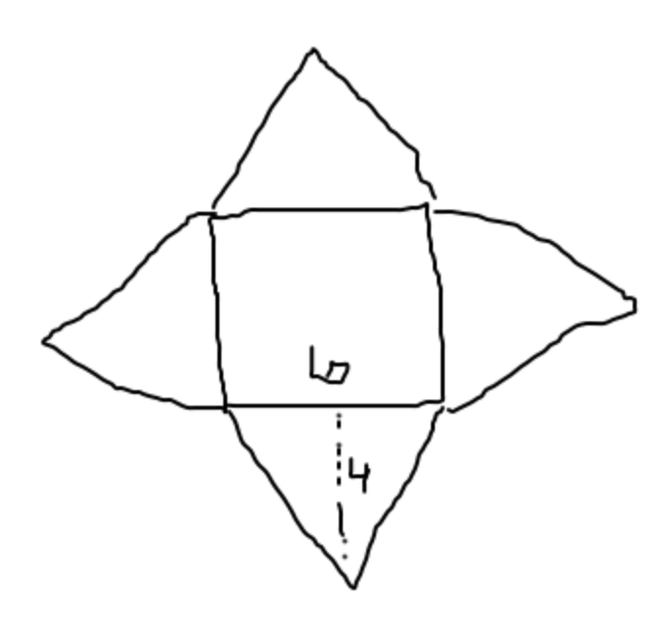

79. You are covering a jewelry box with construction paper. The dimensions of the box are: length of 12 inches, width of 6 inches, and a height of 4 inches. How many square inches of construction paper do you need to buy to cover the box? If Michael’s sells paper for $0.10 per square inch, how much money will you spend on the paper?

ANS: You need 288 square inches of construction paper. You will spend $28.80.

80. You are twice as old as your brother. Together, your ages add to 27. How old are you and your brother?

ANS: You are 18 and your brother is 9.

